**Grazioso Salvare Database Identification Search README**

## **About the Project/Project Title**

*This project is aimed at creating a user-friendly dashboard that displays the related data that Grazioso Salvare requires. When a type or entry is selected, the interactive data such as the geolocation and chart will update.*

**Tools Used**

1. *A Python module that can interact with a MongoDB and provides the basic database functionality of CRUD (Create, Read, Update, Delete).*
2. *PyMongo is the library (engine) that really drives the functionality of this project.*
3. *MongoDB is used to store the data provided in the csv file.*

**Why MongoDB**

*Mongo stores data in flexible JSON-like documents that can vary from document to document and structures can be changed over time. The document models maps to the objects in our application making data easy to work with. The ease of use and support for modern programming languages (in our case, Python) makes it a powerful database tool. MongoDB is also free which is another great reason to use it (published under the AGPL).*

**Why PyMongo**

*PyMongo’s python integration and tools for interactions with a MongoDB makes it a great choice for developing a database management system with its comprehensive CRUD operations. PyMongo performance and efficiency with large databases and community support makes it an easy choice for this project. The methods will be highlighted in the example provided later in the readme.*

**Why Dash Framework**

Dash is a low-code framework for building data apps in Python. The core components module gives us access to many interactive components that brings the interactive interface to life. It integrates well with Plotly, our pie chart for the breed distribution. Dash controller system serves as the mechanism to capture the user inputs and map them to outputs, ensuring that updates are executed in real time.

**Getting Started**

*To get started, download the latest release zip file (Grazioso_v1.zip). Extract the files using your favorite archive program. Make sure both the python script file (.py) and Jupyter Notebook file(.ipynb) are in the same folder. The included Jupyter file already has a template for you to customize as needed.*

## **Installation**

*To use the script, you will need the latest Python release as well as the PyMongo library.*

*Jupyter Notebook to utilize the testing file and your favorite IDE (Personally I like Spyder) to edit Python scripts. You will need to have MongoDB as well.*

*Python:* [*https://www.python.org/downloads/*](https://www.python.org/downloads/)

*Jupyter:* [*https://jupyter.org/*](https://jupyter.org/)

*PyMongo:* [*https://pymongo.readthedocs.io/en/stable/*](https://pymongo.readthedocs.io/en/stable/)

*MongoDB:* [*https://www.mongodb.com/*](https://www.mongodb.com/)

*Dash Framework:* [*https://dash.plotly.com/*](https://dash.plotly.com/)

*Plotly:* [*https://plotly.com/*](https://plotly.com/)

**MongoDB Import Execution (adding additional animal shelters as needed)**

*The following screenshot and command will need to be updated to reflect your user/password and connection settings. The db field will be your database (AAC is for our Austin Animal Center) and collection will be your collection (animals is for our project). The last part (--drop ./aac_shelter_outcomes.csv) will be the file you want imported.*

*Command:*  
*mongoimport --username="${MONGO_USER}" --password="${MONGO_PASS}" --port=${MONGO_PORT} --host=${MONGO_HOST} --db AAC --collection animals --authenticationDatabase admin --type csv --headerline --drop ./aac_shelter_outcomes.csv*

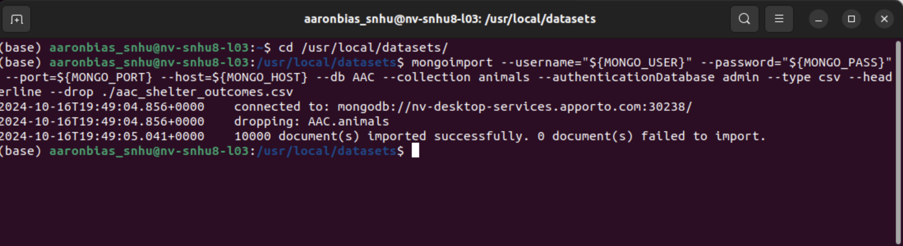

**Usage Demonstration and Fuctionality**

*To connect to your database with the Dashboard.ipynb file. Edit the following section with your username and password and connection settings.*  
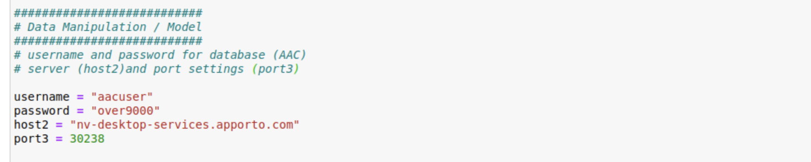

**CRUD Operations**

*The AnimalShelter class will perform basic CRUD operations on the database. The four CRUD functions are listed below for reference. Detailed operations can be found in the animal_shelter.py*

#Create a new Document

#data: Document to be inserted

def create(self, data)

#Quering documents from the specific collection and returning the list of documents if successful or empty if not

#query: parameters to search documents

def read(self, query)

#Update documents in a specified database and collection.

#query: parameters to search documents

#updated_values: new values used for update

def update(self, query, update_values)

#Delete documents from the collection

#query: parameters to search the documents

def delete(self, query)

*Dashboard at startup*

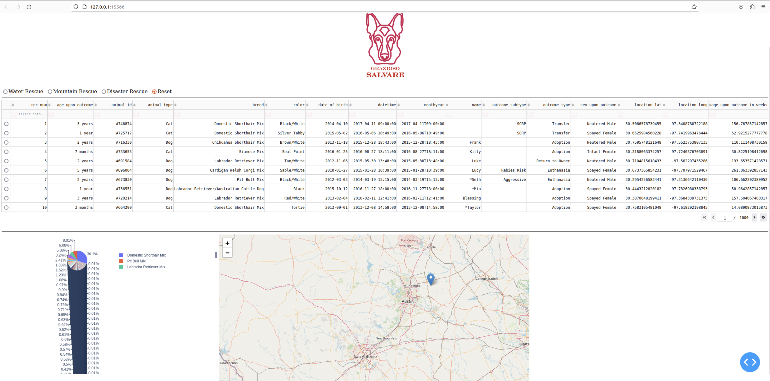

*Water Rescue*

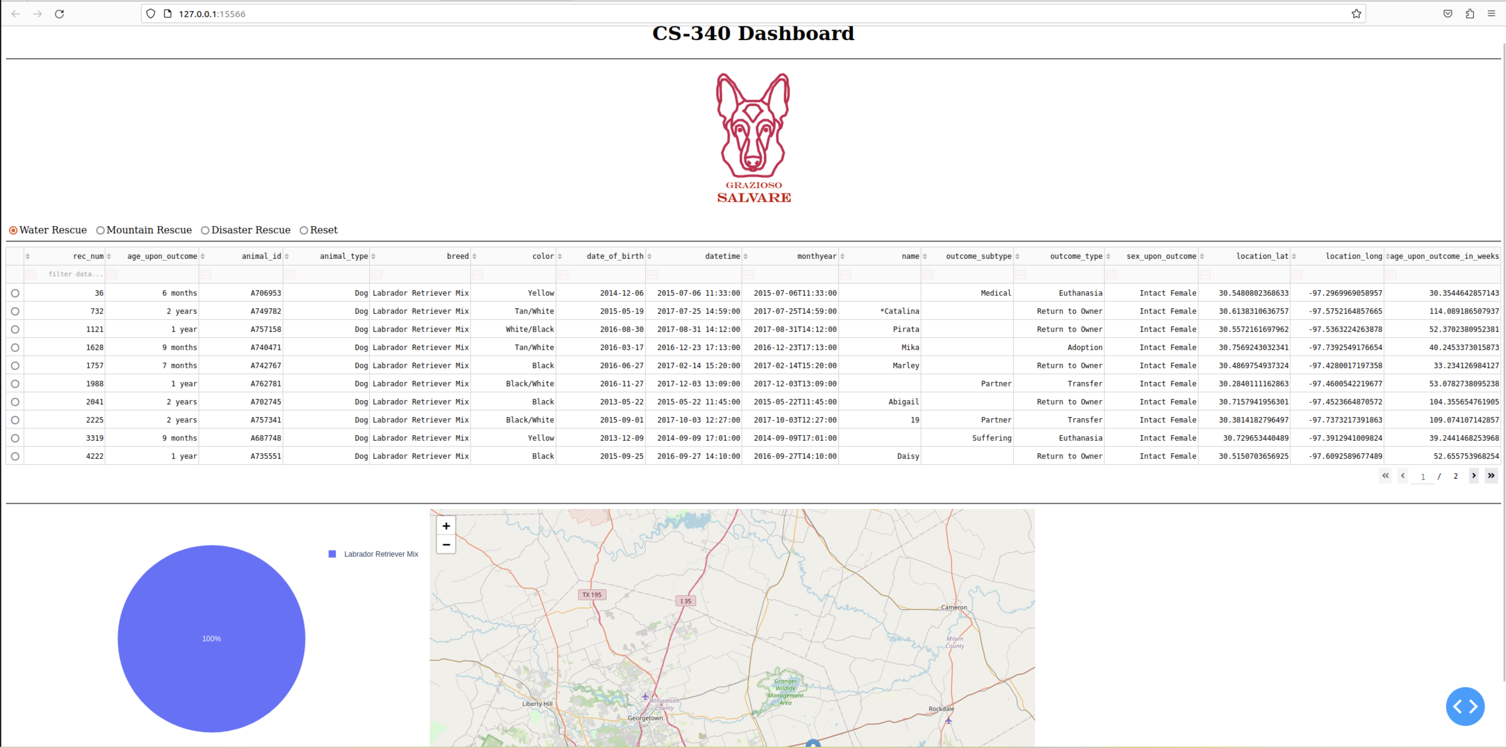

*Mountain Rescue*

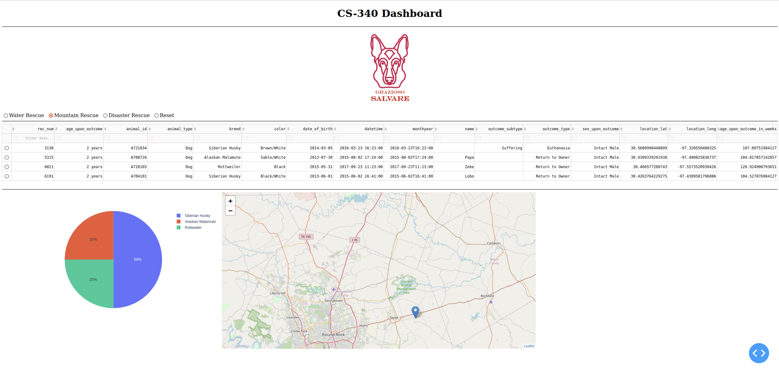

*Disaster Rescue*

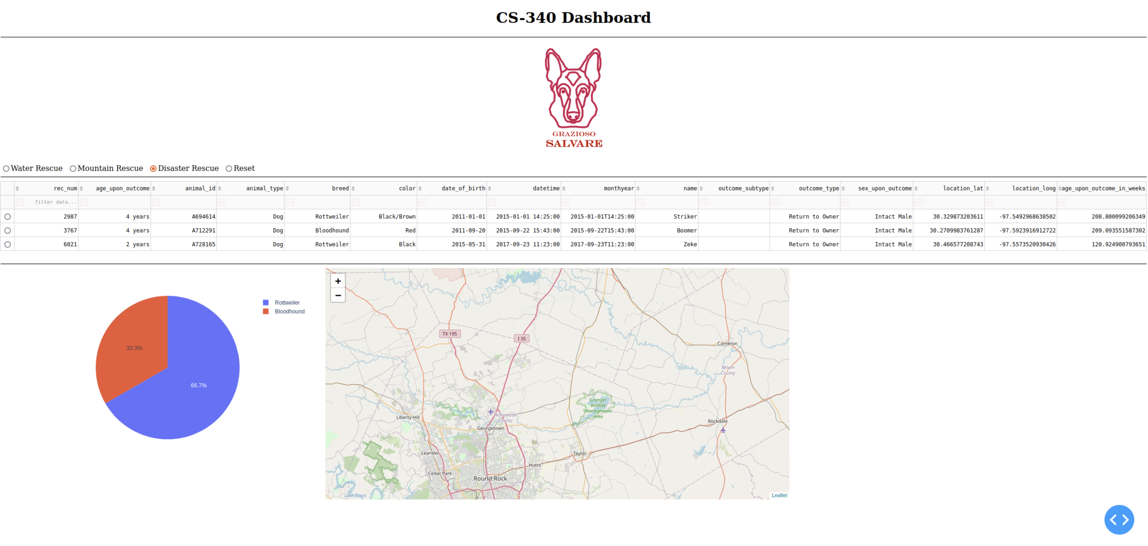

*Reset*

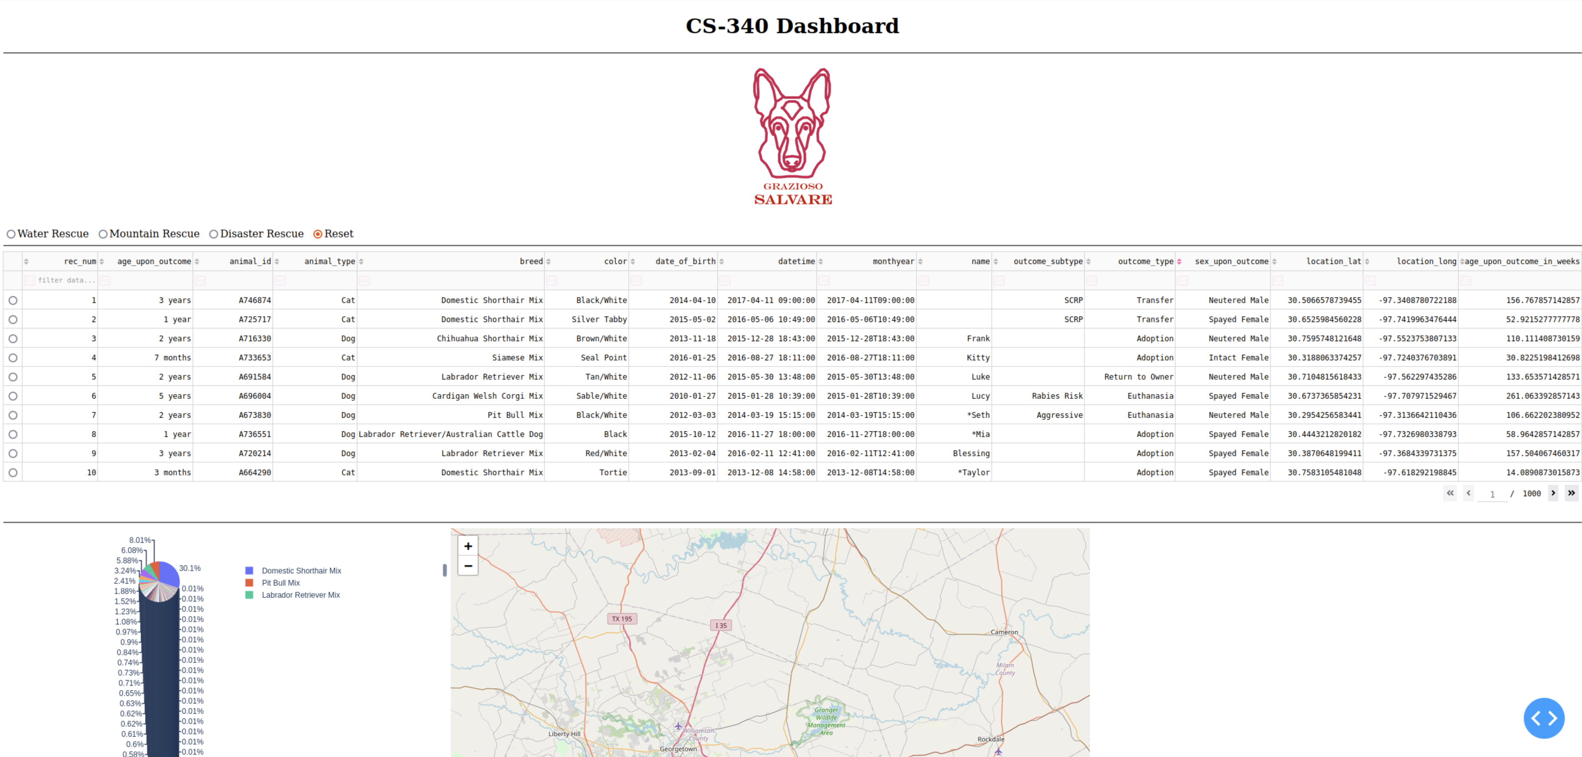**Steps taken to complete projects**

*Creating the database with the right user profiles and roles was the first step in the project. Creating the CRUD operations with the PyMongo library is truly the backbone of this project and provides efficient ways to interact with the data. Mastering the Dash Framework and Plotly libraries gave us interactive options with the data. Testing was crucial in every step of this project as road bumps happened a lot and I still can implement improvements.*

**Challenges**

Time constraints and numerous errors were challenging but provided me with avenues to learn different approaches to problem solving. Updating code and not seeing the changes until I restarted and cleared Jupyter was puzzling until I figured out the intricacies of Jupyter. I still want to practice with the different components of the Dash Framework because of the many ways I could improve the breed information breakdown when selecting types of rescues. I overcame these errors through trial and error and a lot of research. Once I figured out the Jupyter bug (or lack of knowledge on Jupyter), I was able to troubleshoot the remaining issues rather diligently.